STEP1:-Create a web app with amplify console.

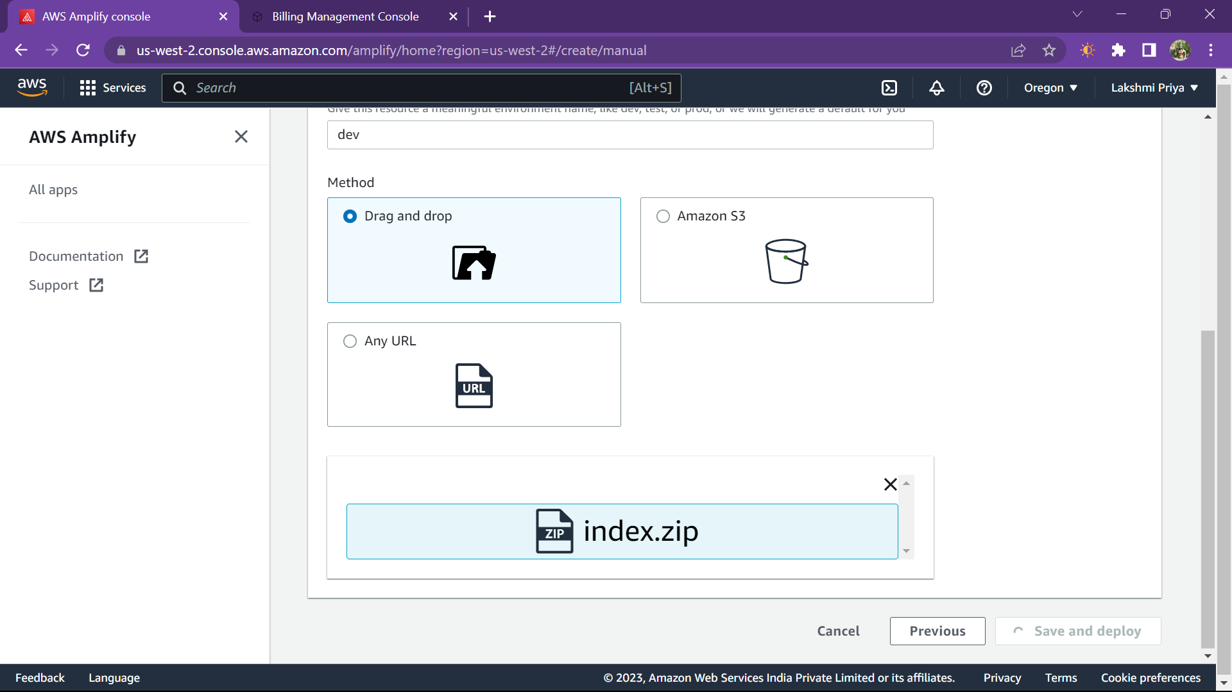

STEP2:BUILD SERVERLESS FUNCTION

STEP3:LINK SERVERLESS FUNCTION TO WEB APP

STEP4:CREATE DATA TABLE

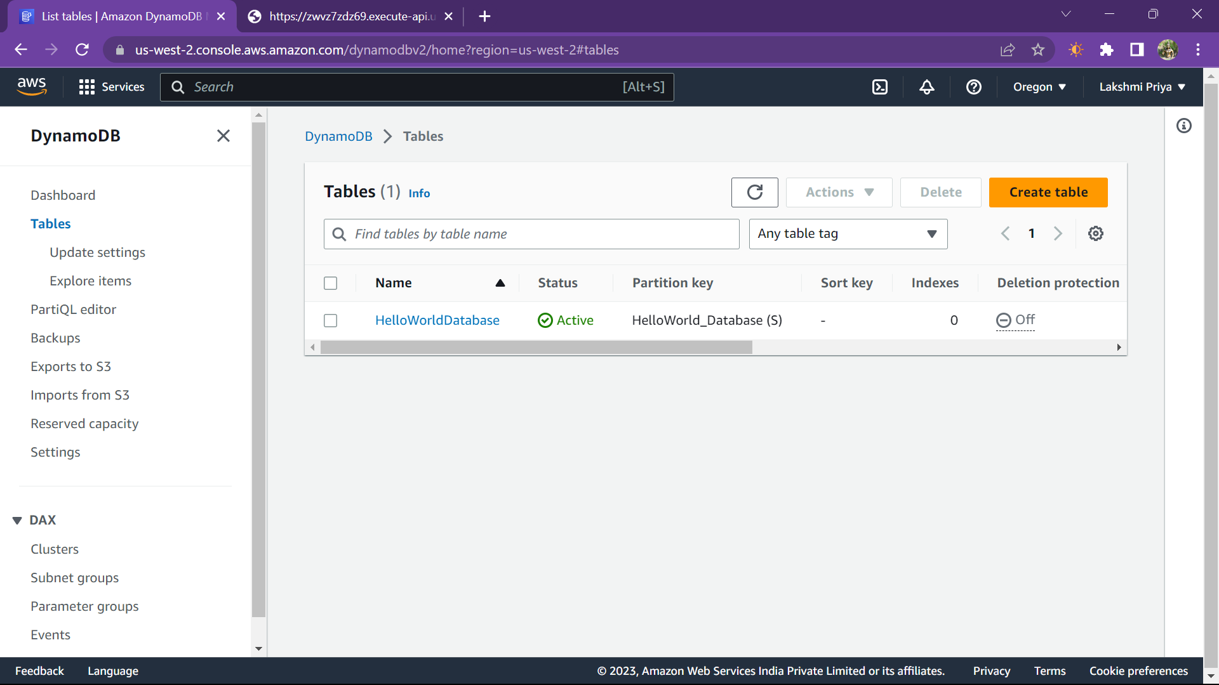

STEP5:ADD INTERACTIVITY TO WEB APP

URL: http://127.0.0.1:5500/index.html